Handling Kubota Orders with ECOM:

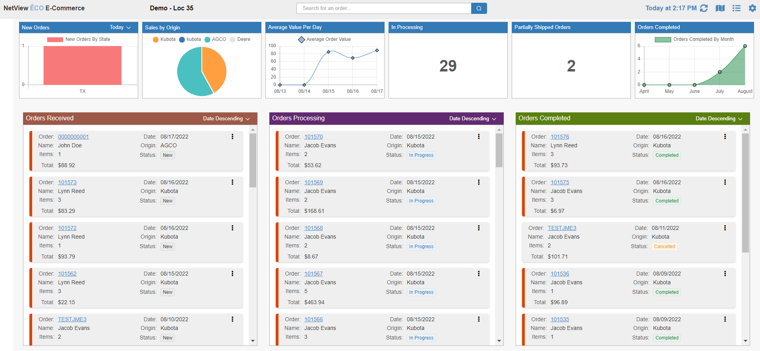

This topic will cover how the E-Commerce Portal (ECOM) works with Kubota Tractor to fulfill online orders made on Kubota’s website through your NetView system, provided you are a Kubota dealer.

Setup Process: To use ECOM for Kubota orders, you must complete the required setup in order for the two programs to work together correctly.

OpenEdge Credentials: Before using ECOM, your dealership will need to send its OpenEdge credentials directly to Kubota.

ECOM Settings: You will need to use the Settings screen in ECOM itself to configure the program to work with Kubota orders. You will have to do this at each individual dealer location that you want to have the ability to process Kubota orders, as the ECOM Settings only function by location.

To access the screen, open ECOM and click the icon in the upper-right corner of the main screen.

[INSERT IMAGE HERE WHEN JACOB FIXES SALESPERSON FIELD LABEL]

Defaults Tab: This tab controls general ECOM settings that are not specific to any one OEM connection. However, these still need to be set before you can use ECOM to process any orders.

- Default Customer: This field sets the default customer that will always be listed on any POS tickets created by accepting a part order purchased via an OEM website. We recommend you create a specific ECOM customer to make keeping track of the tickets and their associated accounting easier.
- Default Salesperson: This field sets the default salesperson that will always be listed on any POS tickets created by accepting a part order purchased via an OEM website. We recommend you create a specific ECOM salesperson to make keeping track of tickets easier.
- Default View: Choose which view you want the main ECOM management screen to open in by default: Column or Table.
- Max Completed: Set the maximum number of recently completed (or cancelled) orders you want visible in the “Completed” column on the main management screen.
- Split Processing Status: This option is currently unavailable.
- Tiles: This option is currently unavailable.

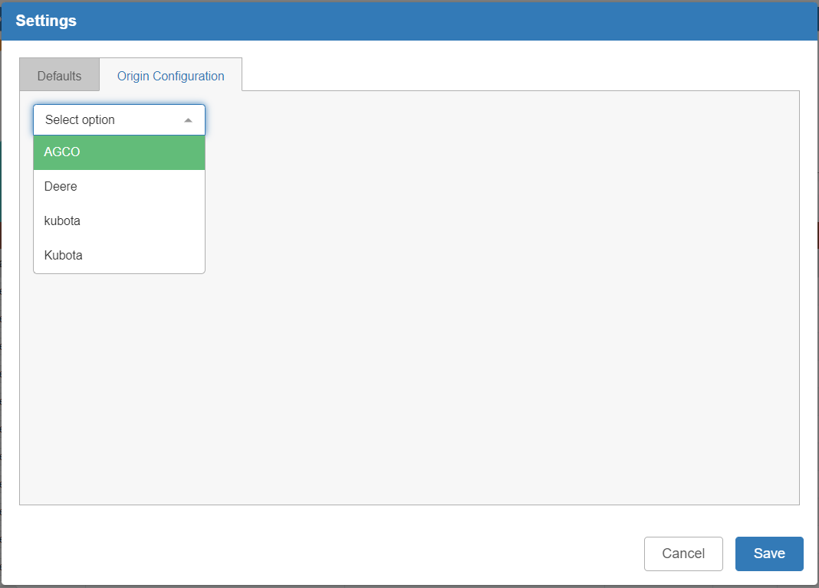

Origin Configuration Tab: This tab manages the configuration settings to have ECOM work with OEM websites and properly import their orders into POS. Select “Kubota” from the drop-down menu to begin setting up your Kubota configuration.

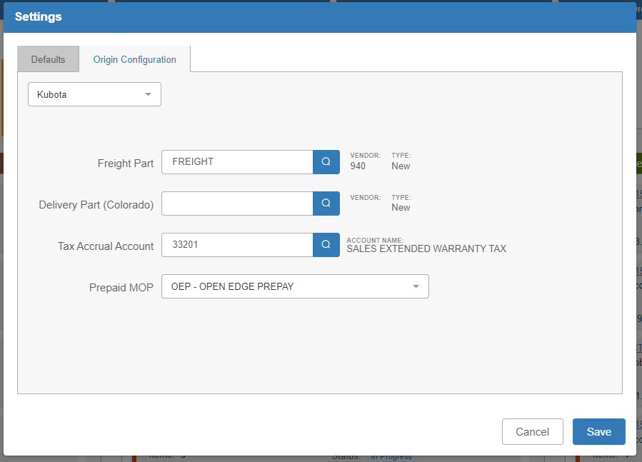

- Freight Part: Enter the specific Freight part number in your system that will be added to POS tickets any time you accept an order with a freight value on it as a way to add the freight charge to the ticket. NOTE: We recommend creating a specific part record for each OEM you work with, especially if you intend to charge different freight values.
- Delivery Part (Colorado): This field is not in use yet.
- Tax Accrual Account: Enter the tax accrual account you wish POS to send the tax amounts from your Kubota orders to when you invoice the orders’ picking tickets.
- Prepaid MOP: Choose the method of payment that POS will automatically select when you accept a prepaid Kubota order through ECOM. We recommend you create a specific MOP to handle prepaid ECOM purchases (or more than one if you wish to use separate MOPs for different OEMs).

Click Save to save your settings in both tabs.

TaxJar Configuration (TJC) Settings: You will need to set up your TaxJar Configuration (TJC) program to work with Kubota’s website in order to ensure tax on the orders gets properly calculated and collected.

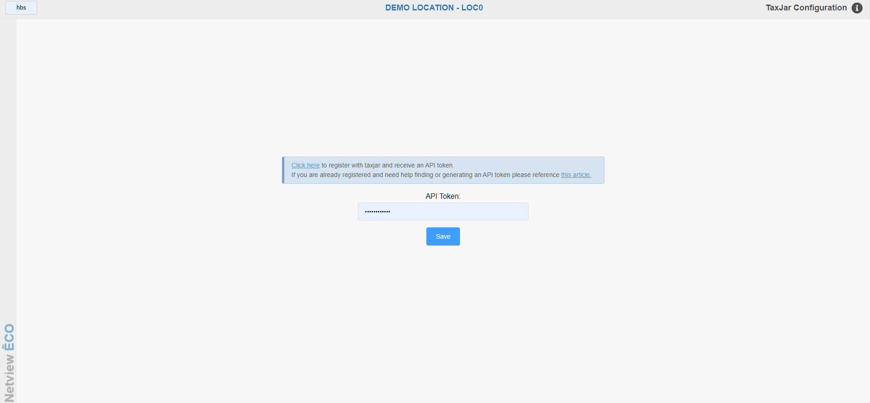

First, make sure you are registered with TaxJar if you have not already. A link to their website will be provided on the main screen in TJC when you first open the program, as shown above. There will also be a link to their Help documentation in the case that you are already registered, but need help finding or generating your API Token. These links are also duplicated below:

TaxJar Registration: https://app.taxjar.com/api_sign_up

TaxJar Token Help: https://support.taxjar.com/article/160-how-do-i-get-a-taxjar-sales-tax-api-token

Once you have your API Token, enter it in the API Token field and click Save. The program will test the token and make sure it is valid. Once it accepts the token, you will be able to access the rest of the screen:

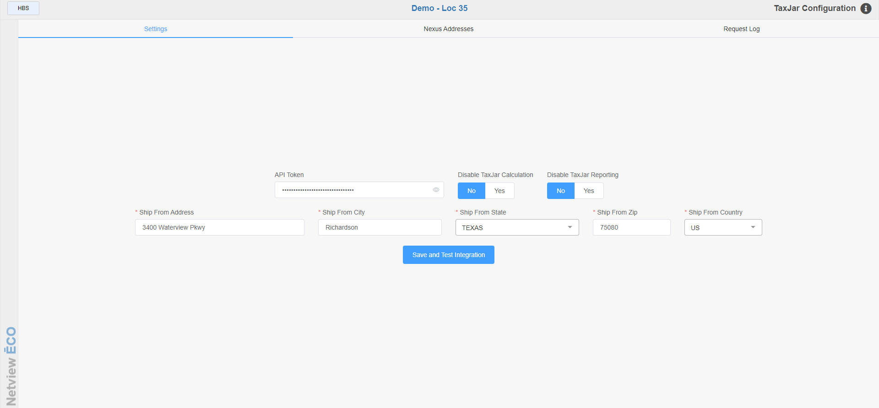

Enter your desired shipping information for tax purposes in the “Ship From” fields. Leave the two “Disable” prompts set to No, as otherwise the TaxJar calculations will not work and you will not have access to any TaxJar reporting. Click Save and Test Integration to store your settings and make sure the integration is working.



Kubota Ordering Process: Kubota orders that show up in ECOM are created by your customers making orders directly to Kubota on their website (URL for US customers: https://shop.kubotausa.com/service-parts-catalog; URL for Canadian customers: https://kubota.ca/parts-catalogue). The customer will select your dealership as their desired provider, and will be able to view your actual inventory and pricing information on Kubota’s website. They will build their desired order, including entering billing, shipping, and payment information, and submit it.

After the customer submits the order to Kubota, it will be made available in the Orders Received section on the main ECOM management screen (column on the far left in the image above). You may have to click the Refresh icon () to have the most recently-submitted orders appear. To begin managing an order, either click the order number or select “View Order” from the Action menu attached to each order (see image below).

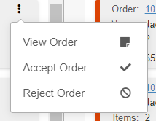

This will open the Order Details screen.

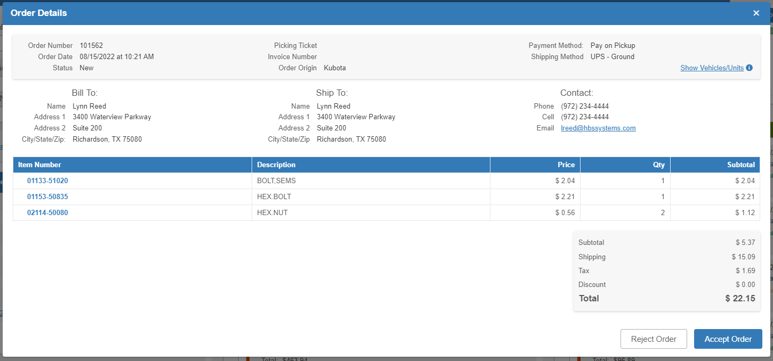

Rejecting an Order: To reject an order after reviewing it in the Order Details screen, click the Reject Order button. NOTE: The Actions menu for each order will also have a “Reject Order” option.

The following alert will appear:

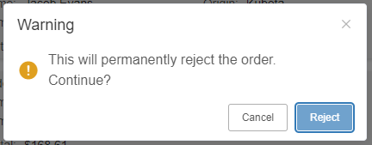

Click Reject to reject the order.



The warning will go away and the order will now be in the “Orders Completed” section (column on the far right) with a “Cancelled” status. NOTE: If you do not see it, it may be due to the max number of completed orders you have set in the Settings screen. You can either change the number to show more orders, or you can look up the specific order number using the Search field at the top of the main ECOM screen.

Refunding a Cancelled Order: If the order was already paid for at the time of cancellation, you will need to go into Parts Point-of-Sale (POS) and manually create a ticket to refund the order.

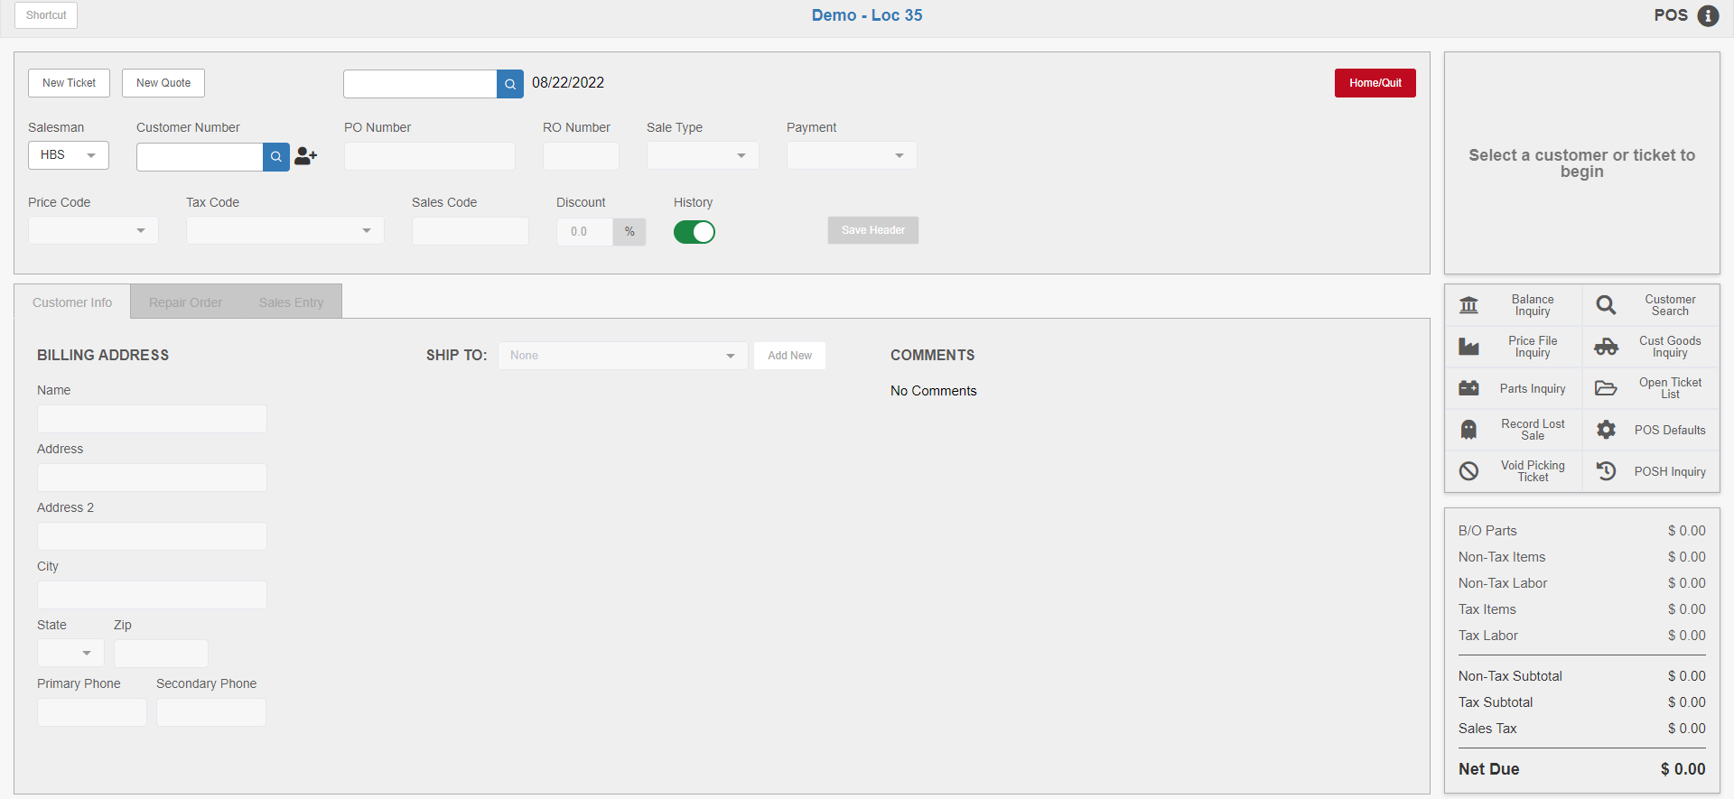

Accepting an Order: You can also accept a received order two different ways. You can open the order’s Details screen and click the “Accept Order” button:

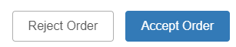

Or you can click the “Accept Order” option on the order’s Actions menu:



The program will immediately start accepting in the order from the OEM. If the parts on the order require a backorder, you will be asked to enter an order number for the backorder at this time:

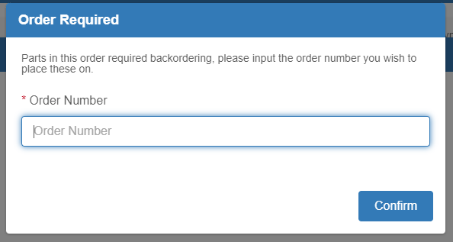

Enter the order number and click “Confirm” to continue. If this is a pay on pickup order, and not a prepaid one, you will also be asked to enter the backorder’s prepaid percentage. The image above is for a prepaid order.

The Accept Order processing screen will show the following when the order is fully accepted in:

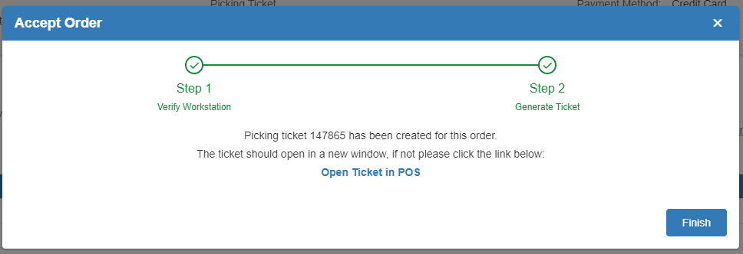

The program will also immediately open the created ticket in POS. If the new POS window fails to open automatically, click “Open Ticket in POS” in the Accept Order screen to open it. Below is an example of what an accepted Kubota order (with freight) will look like in POS:

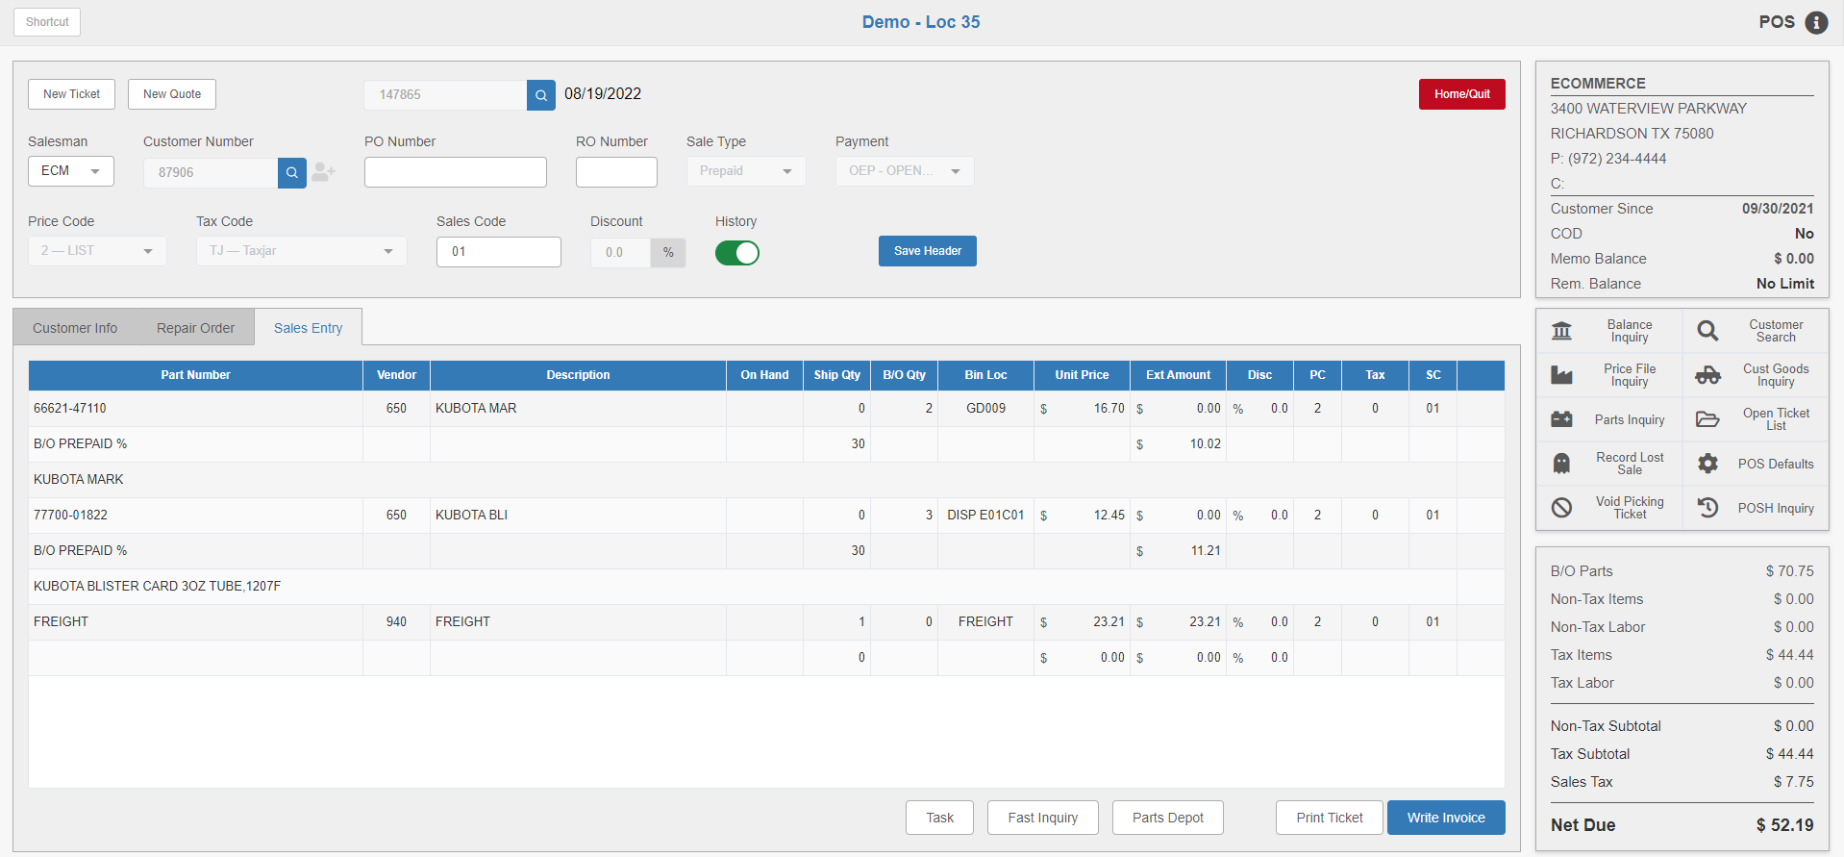

Note that the majority of the ticket will be locked for editing at this point, since you are bringing in a pre-made, and potentially pre-paid, order from an outside seller. At this point you can either invoice the ticket or leave it to return to ECOM.



Finish Acceptance: When you return to ECOM, you will need to click the Finish button in the Accept Order screen to finish the acceptance process in ECOM. This will return you to the main ECOM screen. The order will no longer be listed in the “Orders Received” section, but will now be in the “Orders Processing” section with a status of “In Progress.”

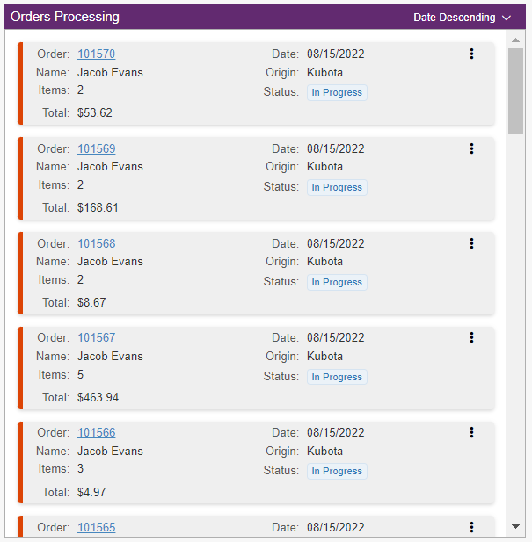

The order’s Details screen will also show the ticket number, which will serve as a hyperlink to the ticket in POS. The hyperlink will stay active until you fully invoice the ticket.

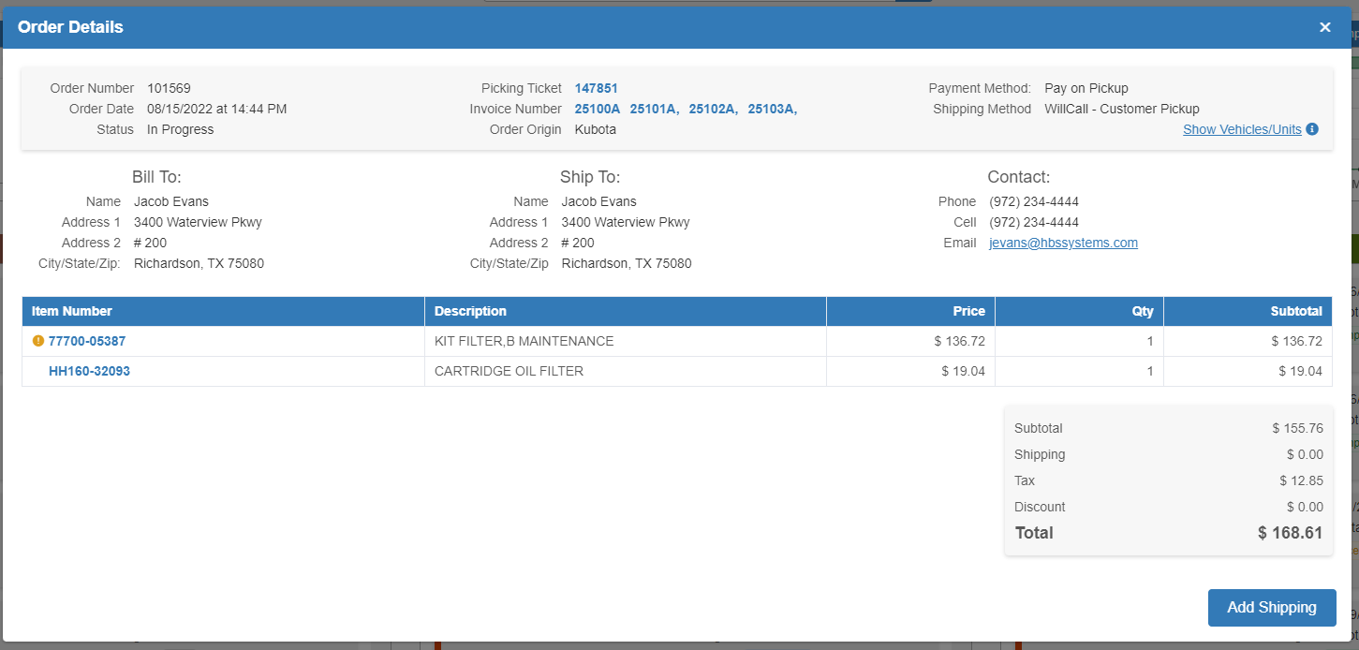

Any invoices you generate for the ticket will have their invoice number(s) listed in the screen as well, and will also serve as hyperlinks which, when clicked, will open a PDF of the invoice.

Shipping and Completing an Order: To begin completing an order in ECOM, you will need to add shipping to it to indicate that you have started fulfilling the order. You can either open an “In Progress” order’s Details and click the “Add Shipping” button:

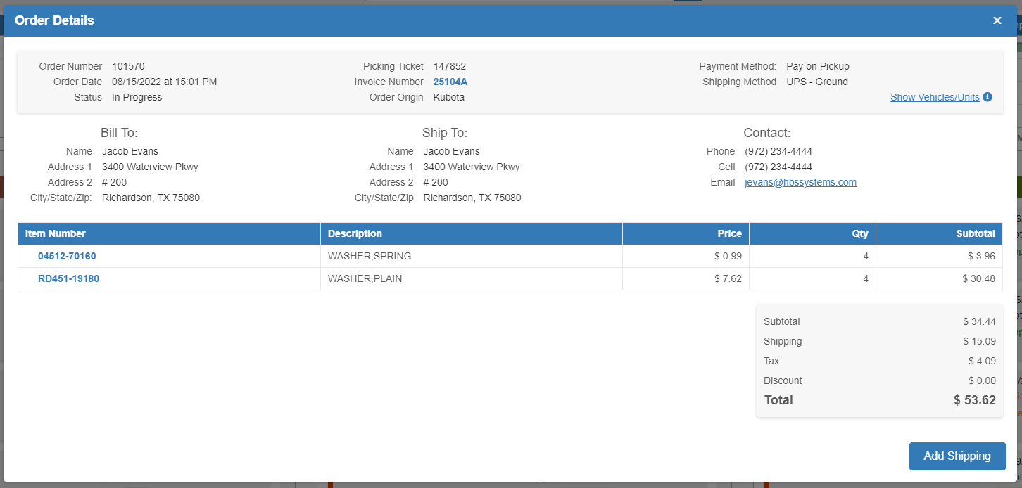

Or you can access the order’s Actions menu and click “Add Shipping” there:

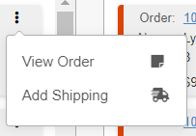

Both options will open the Create Shipment screen:

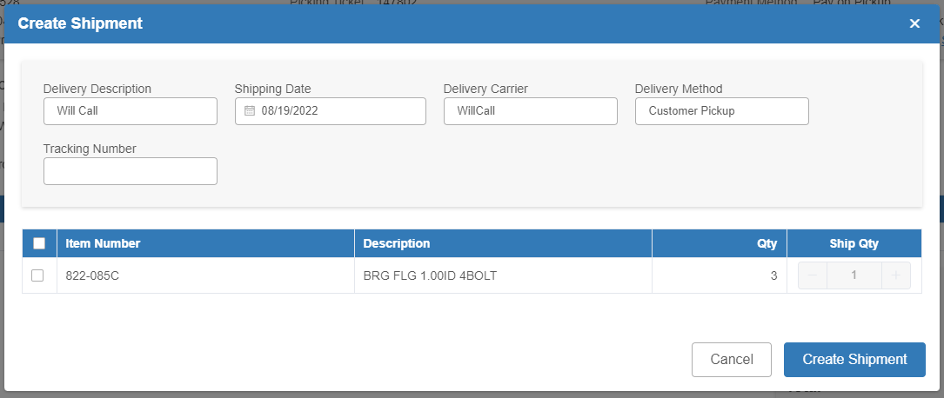

Delivery Description: This field holds the delivery description. It is auto-filled based on the original order, but can be changed if needed.

Shipping Date: This field sets the shipping date for the order. It defaults to the current date, but can be changed as needed.

Delivery Carrier: This field holds the delivery carrier. It is auto-filled based on the original order.

Delivery Method: This field holds the delivery method. It is auto-filled based on the original order.

Tracking Number: This field can hold the order’s tracking number, if applicable.

Item Selection Grid: This grid lists all the items on the order. Select which items will go on the order by checking the box in the far-left column next to the items. This will then let you set the quantity of those items that will come in the shipment using the field in the “Ship Qty” column. You are required to enter a quantity of at least 1 if you have marked the item for the shipment, but if you are unable to send the full quantity in this shipment, you can set it to the partial quantity that will be included. This will allow you to make as many shipments on the order as needed.

Create Shipment: Click this button to close the screen, and update the order’s status. If you only made a partial shipment, the order’s status will change to “Partially Shipped” and it will stay in the “Orders Processing” section.

Viewing Completed Orders: However, if you have finished shipping all items on the order, the order’s status will change to “Completed” and it will be moved to the “Orders Completed” section. You will be able to view it there provided it is among the number of orders you have set to display.

